Template for Evidence(s)
UI GreenMetric Questionnaire

University : ...
Country : ...
Web Address : …

[6] Education and Research (ED)
SAMPLE

[6.9] Number of scholarly publications on sustainability in one year period

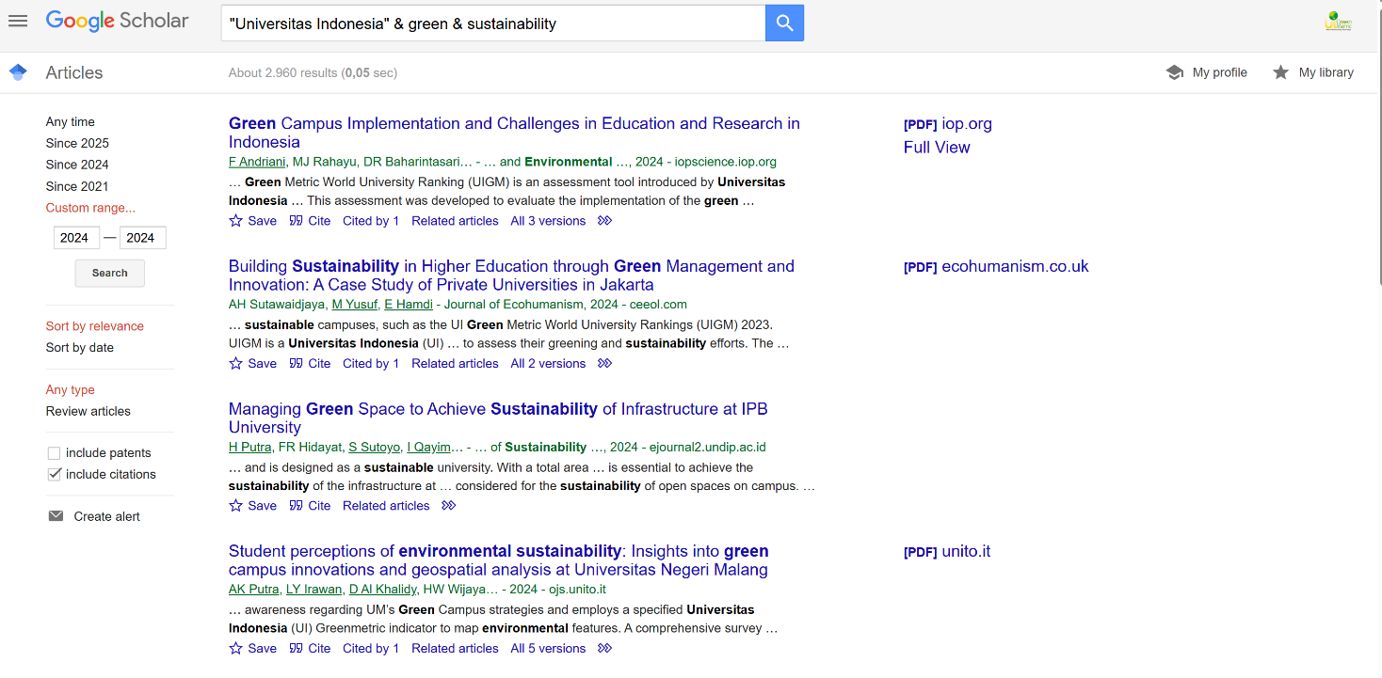
Examples of scholarly publications on sustainability (Universitas Indonesia, Indonesia)

Description:
(Please describe scholarly publications on sustainability. The following is an example of the description. You can describe more related items if needed.)

Example of events scholarly publications on sustainability in the academic year 2024.
A total scholarly publication in 2024 is 2960 publications

Additional evidence link (i.e., for videos, more images, or other files that are not included in this file):

